Stresses on thin walled pressure vessels
Cylindrical or spherical vessels are used in industry to serve as boilers or tanks. These can be analysed easily by considering them as thin vessels. If the ratio of inner radius to wall thickness is greater than or equal to $10 \left(i.e., \frac{r}{t}≥10\right)$, it is considered as thin. The stress distribution over the thickness of the vessel can be assumed to be constant.
Cylindrical vessel  Consider a cylindrical vessel having an inner radius $r$ and wall thickness $t$ subjected to an internal pressure (gauge) $p$. The failure of the vessel can occur either longitudinally or circumferentially. |  | 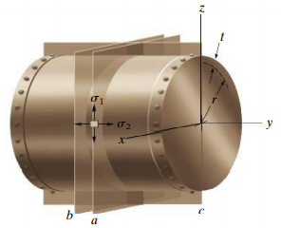  $$p$$
Consider a longitudinal section of length $dy$. The normal stress acting on the section is $σ_{1}.$ From the equilibrium of the forces along the x-direction, we can write,  $$2×σ_{1}×t×dy-p×2r×dy=0 ≫σ_{1}=\frac{pr}{t}=\frac{pd}{2t}$$  This $σ_{1}$is along the length in the circumferential direction and is called circumferential or hoop stress. |  |  | $$t$$  $$σ_{1}$$  $$σ_{1}$$  $$dy$$  $$x$$  $$y$$
Consider a transverse section. The nor mal stress acting on the section is $σ_{2}.$ From the equilibrium of the forces along the y-direction, we can write,  $$σ_{2}×2πrt-p×πr^{2}=0 ≫σ_{2}=\frac{pr}{2t}=\frac{pd}{4t}$$  This $σ_{2}$is along the circumference in the longitudinal direction and is called longitudinal stress. |  | 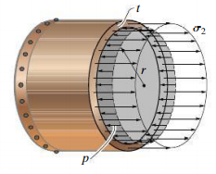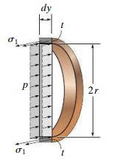
The hoop stress is twice the longitudinal stress in cylindrical vessels. Both are tensile stresses. While fabricating cylindrical pressure vessels, the longitudinal joints must be designed to carry twice as much stress as the circumferential joints. |  | 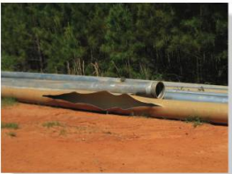
Spherical vessel  In spherical vessels, there is only circumferential stress ($σ_{1}=σ_{2})$  $$σ_{1}×2πrt-p×πr^{2}=0 ≫σ_{1}=\frac{pr}{2t}=\frac{pd}{4t}$$ | 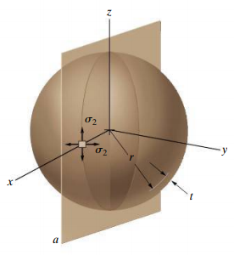 |  |  | 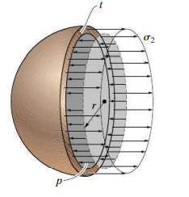
Any element on the surface of the thin vessels will be in a state of bi-axial tensile stress. They are also the principal stresses. On the outer surface, the third principal stress$σ_{3}=0$. But on the inner surface, the third principal stress $σ_{3}=-p$

Mohr circle for cylindrical vessel (outer surface) $(σ_{1}, σ_{2}, 0)$  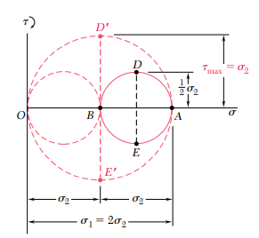 | Mohr circle for spherical vessel (outer surface) $(σ_{1}, σ_{1}, 0)$  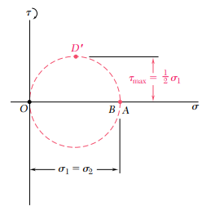
Mohr circle for cylindrical vessel (inner surface) $(σ_{1}, σ_{2}, -p)$ | Mohr circle for spherical vessel (inner surface) $(σ_{1}, σ_{1}, -p)$

#Example 1  A compressed air tank is supported by two cradles as shown; one of them is designed sothat it does not exert any longitudinal force on the tank. The cylindrical body of the tank has a $0.75 m$ inner diameter and is fabricated from a $10 mm$ thick steel plate by butt welding along a helix that forms an angle of $25°$ with a transverse plane. The end caps are spherical and have a uniform wall thickness of$7 mm$. For an internal gauge pressure of $1.25 MPa$, determine (a)the normal stress and maximum shear stress in the spherical cap (b) the stresses in the directions parallel and perpendicular to the weld. |  | 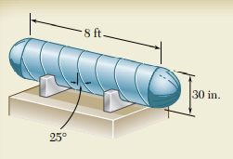  0.75m  2.5m
Spherical cap  $$p=1.25 ×{10}^{6}Pa ≪≫t=7 mm≪≫ d=0.75 m$$  $$σ_{1}=σ_{2}=\frac{pr}{2t}=\frac{pd}{4t}=\frac{1.25 ×{10}^{6}Pa×0.75 m}{4×7×{10}^{-3}m}=33.5×{10}^{6}Pa$$ | 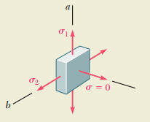
For a spherical cap, the biaxial principal stresses are equal and the Mohr circle reduces to a point (A, B) on the horizontal axis and the in plane shear stresses are zero. The third principal stress on the surface is zero corresponding to O. The maximum out of plane shear stress $τ_{max}=CD^{'}=16.75 MPa$ |  | 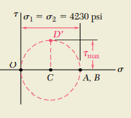  33.5 MPa
Cylindrical body  $$p=1.25 ×{10}^{6}Pa ≪≫t=10 mm≪≫ d=0.75 m$$  $$σ_{1}=\frac{pr}{t}=\frac{pd}{2t}=\frac{1.25 ×{10}^{6}Pa×0.75 m}{2×10×{10}^{-3}m}=47×{10}^{6}Pa$$  $$σ_{2}=\frac{pr}{2t}=\frac{pd}{4t}=\frac{1.25 ×{10}^{6}Pa×0.75 m}{4×10×{10}^{-3}m}=23.5×{10}^{6}Pa$$ |  | 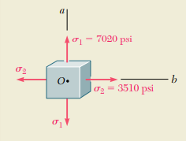  23.5 MPa  47 MPa
$σ_{ave}=\frac{{σ_{1}+σ}_{2}}{2}=35.25 MPa ≪≫R=\frac{{σ_{1}-σ}_{2}}{2}=11.75 MPa$  $$θ=25°$$  $$σ_{weld}=σ_{ave}-Rcos 50=27.7 MPa$$  $$τ_{weld}=R sin 50=9 MPa$$ |  | 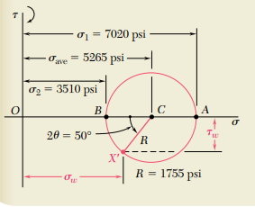  47 MPa

Exercise 1  The steel pressure tank has a 750 mm inner diameter and 9mm wall thickness. Knowing that the butt-welded seam form an angle $β=50°$ with the longitudinal axis of the tank and that the gauge pressure inside the tank is 1.5 MPa, determine the stresses parallel and perpendicular to the weld. | 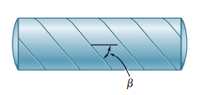
Exercise 2
A spherical gas container made of steel has a 5m outer diameter and a wall thickness of 6mm. If the internal pressure is 350 M Pa, determine the maximum normal stress and shear stress in the container

References
- Mechanics of Materials, 2/e, J. M. Gere & S. P.Timoshenko, CBS Publishers.
- Mechanics of Materials, 6/e, F.P. Beer & E. R. Johnston, McGraw Hill
- Engineering Mechanics of Solids, 2/e, E. P. Popov, Pearson Education Asia.
- Mechanics of Materials, 9/e, R. C. Hibbeler, Prentice Hall.

